PHASE 5 – TESTING AND VALIDATION

5.1 Introduction
- Testing is an important process used to verify whether the implemented features work correctly. In this project, testing is performed to validate UI Policies and Client Scripts in the ServiceNow Incident Management module.

5.2 Testing Objectives
- To verify UI Policy conditions.
- To check mandatory field validation.
- To verify automatic field population.
- To prevent invalid form submission.
- To validate list editing restrictions.
- To ensure correct Incident form behavior.

5.3 Test Cases
Test Scenario: Select Impact as High.
Expected Result: Assignment Group becomes mandatory.
Status: To be verified.

Test Case 2: Urgency Read-only
Test Scenario: Select High Impact.
Expected Result: Urgency field becomes read-only.
Status: To be verified.

Test Case 3: Automatic Urgency Update
Test Scenario: Change Impact to High.
Expected Result: Urgency is automatically set to High.
Status: To be verified.

Test Case 4: Assigned To Validation
Test Scenario: Submit a High Impact incident without selecting Assigned To.
Expected Result: An error message is displayed and form submission is prevented.
Status: To be verified.

Test Case 5: Successful Submission
Test Scenario: Select Assigned To and submit the High Impact incident.
Expected Result: The form is allowed to submit.
Status: To be verified.

Test Case 6: Reverse UI Policy
Test Scenario: Change Impact from High to Medium.
Expected Result: The UI Policy condition is reversed and the original field behavior is restored.
Status: To be verified.

Test Case 7: State List Editing
Test Scenario: Try to modify the State field directly from the Incident list.
Expected Result: An alert message is displayed and the list edit is rejected.
Status: To be verified.

Test Case 8: Form-based State Update
Test Scenario: Open the Incident record and update the State through the form.
Expected Result: Form-based update is allowed.
Status: To be verified.

5.4 Testing Summary
- The test cases are designed to verify the functionality of UI Policies and Client Scripts. Each test case will be checked in the ServiceNow platform, and the actual result will be recorded after execution.
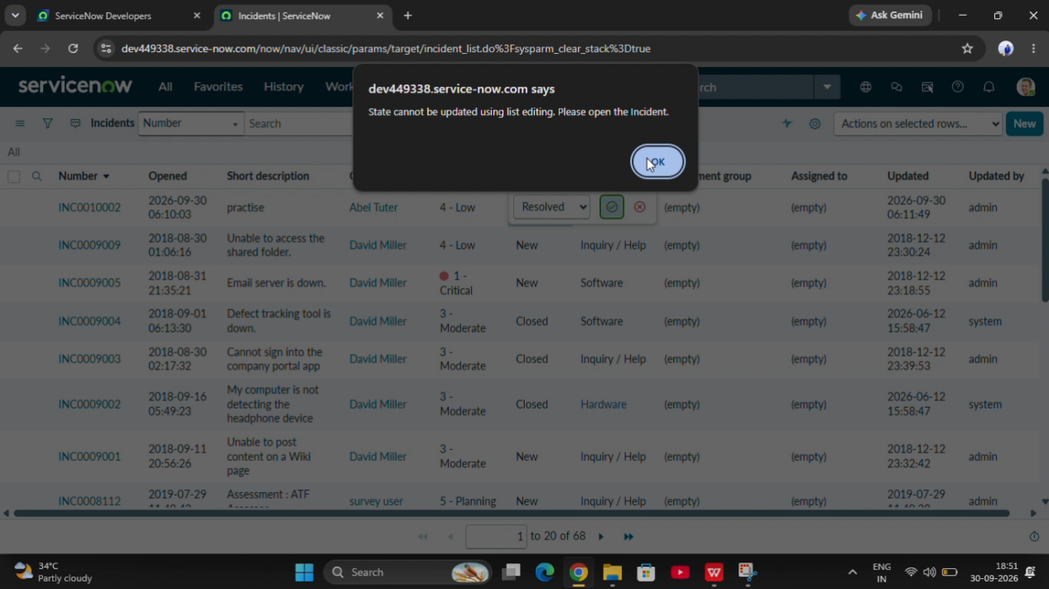

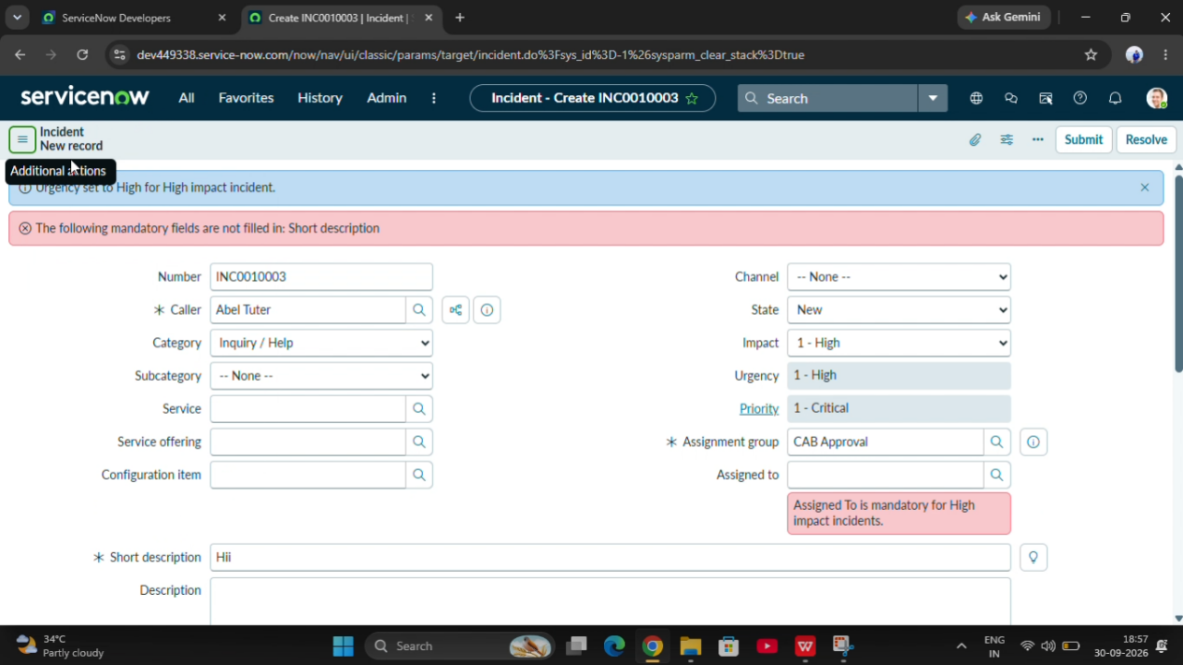

5.5 Conclusion
- Testing and validation help ensure that the Incident form behaves according to the project requirements. The implemented conditions are verified to improve data accuracy, field control, and form submission validation.

